**6. NETWORKS**

**Networks: Types of networks (wired, wireless, LAN, WAN, MAN, PAN). Network topologies. Web basics. The Internet technology. IoT.**

1. What is Internet?
2. What is network? How can networks be classified?
3. What are the main Internet connections?
4. What are the main network topologies?
5. What is Internet of Things? What are the examples of IoT?

**INTERNET**

The Internet began in 1969 as ARPAnet, a U.S. Department of Defense project to create a computer network that could withstand a nuclear war. During the next two decades, the network that evolved was used mainly by universities, scientists and the government for research and communications. The nature of the Internet changed in 1992, when the U.S. government offered Internet **access** to the general public. The number of users grew rapidly into the millions and then hundreds of millions. The main reasons for this massive increase were the huge growth of the personal computer market, the invention of the World Wide Web by Tim Berners-Lee in the early 1990s, and the widespread adoption of **broadband** in the 2000s.

**WEB BASICS. TYPES OF NETWORKS**

A computer network is a group of computers linked to each other that enables the computer to communicate with another computer and share their resources, data, and applications. You can think of a **network** as a spider web with many interconnecting points, referred to as **node**. A network node usually contains a computer, networked peripheral, or network device. The most important network device is a **router,** which acts as a central distribution point for getting data to its destination. Data in a network with wired connections travels from one device to another over cables. Wired connections are fast, secure and simple to configure. An example of wired network technology is **Ethernet**. A wireless network transports data through the air, eliminating the need for cables. Wireless connections transport data as **RF signals** (radio frequency signals), **microwaves** and **infrared light beams**. The most popular wireless technology is **WI-FI**. Additional wireless technology is **Bluetooth** (a short-range wireless network technology that is designed to make connections between two devices).

Networks can be classified according to their size and geographic scope:

**PAN (Personal area network)** is a network arranged within an individual person, typically within a range of 10 meters. PANs can connect laptops, tablets, printers, keyboards, and other computerized devices.

**LAN (Local area network)** is a group of computers connected to each other in a small area such as building, office.

**MAN (Metropolitan area network)** is a network that covers a larger geographic area by interconnecting different LANs to form a larger network.

**WAN (Wide area Network).** A Wide Area Network is a network that extends over a large geographical area such as states or countries. The Internet is one of the biggest WAN in the world.

**TYPES OF INTERNET CONNECTION**

**Dial-up and DSL** (digital subscriber line): a way to connect to the Internet through a telephone connection.

**Cable**: uses the same infrastructure as a cable television.

**Wireless**: uses radio frequency bands. You simply need a modem and an account with an Internet Service provider (ISP).

**Satellite**: access to the Internet via satellite. The connection is slightly slower than through cables, but it's a good option for areas where other types of connections are not available (rural areas).

**Fiber-optic** is currently the fastest type of Internet available. It uses glass fiber-optic threads to transfer light signals, which are fast and reliable over long distances.

**NETWORK TOPOLOGIES:**

A **network topology** is the layout of the interconnections of the nodes of a computer network. It depends on the distance involved, the type of hardware used, stability, scalability and cost.

In a **bus network** all nodes are connected to a **backbone** (core network which interconnects networks). Bus topologies were often used in smaller networks. One of the main reasons is that they keep the layout simple.

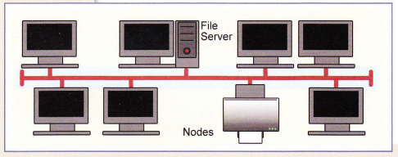

**Star topology**is by far the most common. Within this framework, each node is independently connected to a central **hub or switch** via a physical cable creating a star-like shape. Once it has received a signal, the hub passes it to all the other nodes until it reaches the destination computer. This topology is commonly used in businesses. Thanks to this topology, data is always up-to-date and if a computer doesn't work, it doesn't affect the others. The only disadvantage to it is that if the hub goes down, the whole network doesn't work.

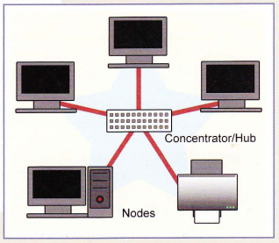

In networks with **ring topology**, computers are connected to each other in a circular format. Every device in the network will have two neighbors. As it requires fewer cables, this topology is less expensive. Ring topologies were commonly used in the past but you would be hard-pressed to find an enterprise still using them today.

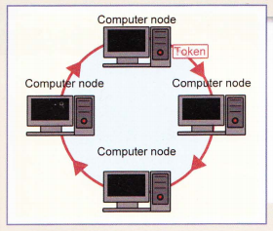

When a topology is composed of two or more different topologies it is referred to as a **hybrid** topology. Hybrid topologies are most-commonly encountered in larger enterprises where individual departments have network topologies that different from another topology in the organization. **Star-bus** topology combines elements of star and bus topologies to create a more effective network. Computers in a specific area are connected to hubs creating a star, then each hub is connected together along the network backbone.

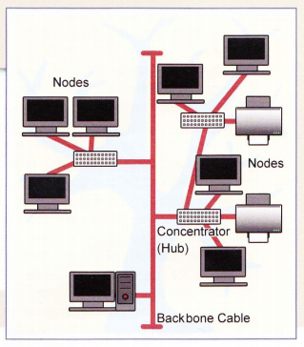

**IoT (INTERNET OF THINGS)**

The Internet of Things (IoT) describes the network of physical objects—“things”—that are embedded with **sensors**, software, and other technologies for the purpose of connecting and exchanging data with other devices and systems over the Internet. These devices range from ordinary household objects to sophisticated industrial tools. Sometimes, IoT devices communicate with other related devices and act on the information they get from one another. The devices do most of the work without human intervention, although people can interact with the devices - for instance, to set them up, give them instructions or access the data. Over the past few years, IoT has become one of the most important technologies of the 21st century. With more than 7 billion connected IoT devices today, experts are expecting this number to grow to 22 billion by 2025.

The following are some common uses for IoT:

* Home automation (smart home)
* Wearable health monitors
* Smart cars
* Process automation
* Smart cities
* Smart farming